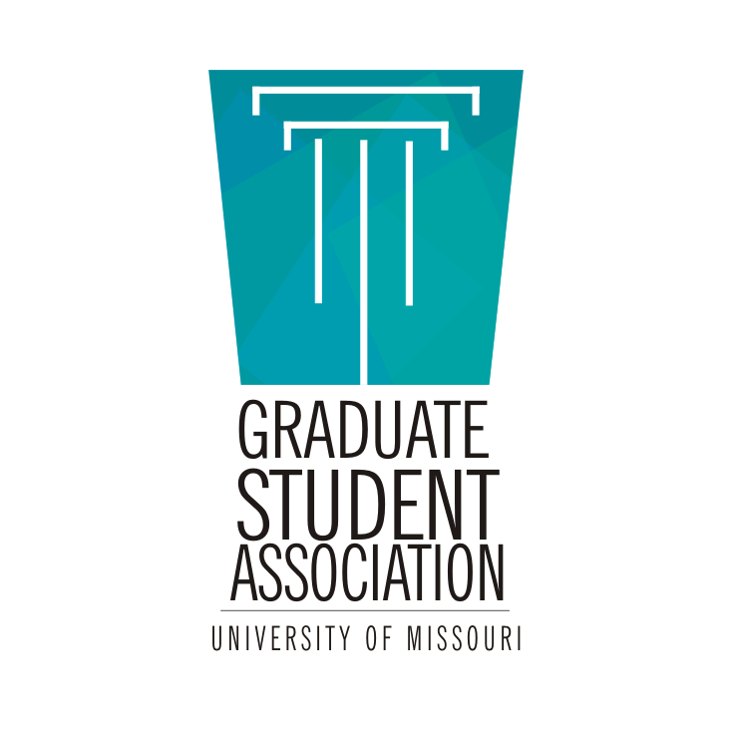
GSA General Council Meeting Agenda
September 26, 2017
6:00 PM, Gwynn Hall 220

- Call to Order -- 6:02 PM
- Approval of the Agenda -- PR moves, Rural Sociology seconds. Approved.
  - Secretary moves to strike April minutes from list due to lack of minutes from prior administration. Seconded by Fundraising. Approved.
- Approval of Minutes
  - August -- History moves, VP seconds. Approved.
  - Motion to suspend the rules to allow the VP to chair the meeting. PR moves, Special Education seconds. Approved.
- Officer Reports
  - President
    - President attended Graduate Faculty Senate on 9/26. The travel ban affects 62 students at MU, 57 of whom are grads. International Center will work with affected students. International Center urges students to contact them expeditiously for counseling. Current thought is that affected students should not risk traveling outside the US.
    - Dr Hart said it can be assumed there will be no changes to insurance or tuition waivers for next year. Departments are able to use that for recruitment. Tuition waivers are still on the table as a source of revenue for the future, however.
      - Philosophy: .25 tuition waivers are especially being considered for cuts, as the CFO desires it.
  - Vice President
    - CVDocs last Wednesday. Generally positive feedback. There will be a spring session as well. The Constitutional Bylaws Committee will begin in the next week. VP urges anyone interested to join.
  - Treasurer
    - Treasurer introduces himself. $5,599 carry-forward from previous executive. Will recieve new allotment of ~12,000 in spring. Next travel cycle ends on Monday, October 2nd, for travel between June 15 and Sept 14. Cycle 4 covers Sept 15 through Dec 14. Budget renewal process is happening now through the Student Fee Review Committee. Treasurer will find out shortly when the SFRC hearing is.
  - Secretary
    - Nothing to report.
  - Fundraising
    - Looking into several different fundraising options, including a profit share event at Shakespeare’s in December. Also looking at opportunities for fundraising for disaster relief.
  - PR
    - PR reports GSA has increased its like-growth compared to last year. Reps, continue to communicate to constituents to like the Facebook page.
- Old Business
  - Graduate Education Week
    - Week of October 15th. Events include a visit from Jennifer Polk, alt-ac advisor and blogger of From PhD to Life. Other events: First impressions workshop for graduate students; learn about cues and first impressions, useful for job market and teaching. OGS will hold a workshop about the forms necessary for progress, especially useful for international students. President asks what questions may be useful in this event or other OGS events.
      - LTC: How to find unofficial transcripts.
      - Theatre: IRB process? Prez: May be a good seperate event.
      - Special Education: “Divorcing advisor” advice?
      - Sociology: Worked at IRB in undergrad!
      - Philosophy: Does not believe we have unofficial transcripts, though we should.
  - Writers’ Room
    - Begins this Thursday, 9/28, in Ellis 4F. Anne Barker and Tim Perry/Kelly Hansen, “What Can Your Librarians Do For You?” “Citation Services (Zotero, etc.)” next week.
    - There is a prize! Every time you attend you get an entry into a prize drawing. Winner gets $150 from Mizzou Store.
- New Business
  - Other writing spaces for grads
    - President is looking for other writing spaces for grads. Currently there are carrels in the library for $50 semester. Art and Architecture Museum at MU North is creating a pilot program for grads to write there.
      - Philosophy - is parking free? Consensus seems to be yes.
    - MU Extension buildings are interested in bringing more writing space to grads, possibly including child care space.
    - CAFNR’s research facility, Bradford Farm, is also a possibility.
    - President welcomes further suggestions for a resource list.
  - New Chancellor’s Task Force - International Teaching Assistant Program Review
    - Looking for an international student TA or Grad Instructor to serve on this committee. Looking at waivers for requirements for international grad TAs and how to make the program more ethically guided; as it is, the requirements tend to favor European and majority-white nations. One practical element is that these requirements can delay a teaching assignment even for students who meet the requirements.
  - Findings from March ‘16 Survey regarding graduate recruitment
    - President will send out a report regarding graduate recruitment survey. Highlights: ⅕ of grads expect or have children; int’l students feel they are worked harder; African-American students have higher satisfaction than other people of color, perhaps due to groups like ABGPS.
  - Avoiding a proposed student fee for graduation
    - There is a proposal to add a student fee. Dr Hart opposes this. There are two manual checks for graduation, which means a lot of labor, which is justification for the fee. Suggestion is to instead add another step to the process where an advisor would confirm the readiness of a grad student to graduate.
      - PR: If fee is inevitable, could the fee be associated with receiving diploma rather than in application? Prez: Fee is not inevitable; there is pushback from faculty as well.
      - Philosophy: Could fee be assessed to departments?
      - IMSE: Fee for changing graduation semesters rather than applying?
      - MPP: How much is the fee? Prez: Was not specifically named.
- Announcements
  - Secretary: Go to the Student Affairs fora! They cover fees!
  - Philosophy: Student Affairs also covers student groups and health insurance - the student health center now charges insurance and copays for visits. Director of Student Health had opportunities to make other choices; he will be at GPC meeting next week in Leadership Auditorium.
  - PR: After Orlando is happening! Secretary will send out fliers. Sunday October 8th in Wrench Auditorium.
- Adjourn - President moves, Philosophy seconds.

